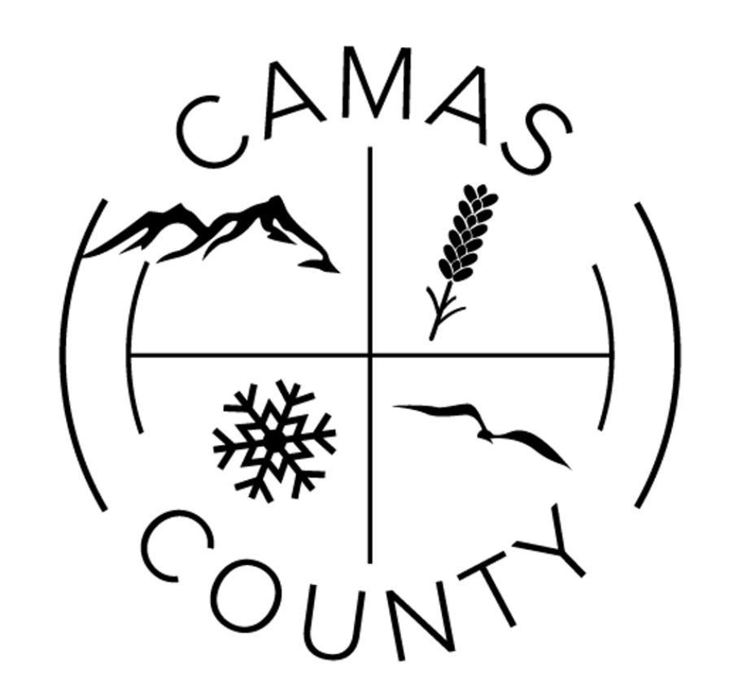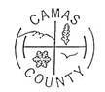
Camas County Board of Commissioners
Camas County Courthouse Annex, 517 Soldier Road
Commissioners Room
April 20th, 2026

9:00 a.m. -5:00 p.m. (as time permits)
*Correspondence/Committee Reports
**Idaho Wool Growers Association – Nomination.
**Resolution- destruction of County records.
**Clerk’s quarterly financial report
*Discussion on employee time sheets
*Discussion on State Drought Declaration

9:00 a.m.

*Call to Order
**Approval of the Agenda
**Review/ approve April 13, 2026 Meeting Minutes
**Review/ approve April 13, 2026 Synopsis for Commissioner Publication

9:15 a.m.-

9:30 a.m.- Tax Deed Sale requirements.

9:45 a.m.-

10:00 a.m.- Yvonne Humohrey – South Central Public Health District – Proposed Budget.

11:00 a.m.- Camas County Courthouse 501 Soldier Rd, Fairfield, Id 83327 Upstairs in the Courtroom **Executive Session, per Idaho Code §74-206(f), as needed for pending litigation.

12:00 p.m.- 1:00 p.m. Lunch

1:00 p.m. – Carol Regan & Cindy – Extension office annual report, Price quote for south side of the Annex building flower bed gravel.

NOTE: Meetings are open to the public except for executive sessions. However, if you are not on the agenda, you may not be recognized to speak. If you would like to speak during the meeting, please contact the County Clerk’s office to be placed on the agenda by Thursday prior to the meeting. Please contact the clerk’s office prior to any county meetings if there is any special assistance needed for people planning to attend. (208) 764-2242
**Refers to matters that an action is required**

