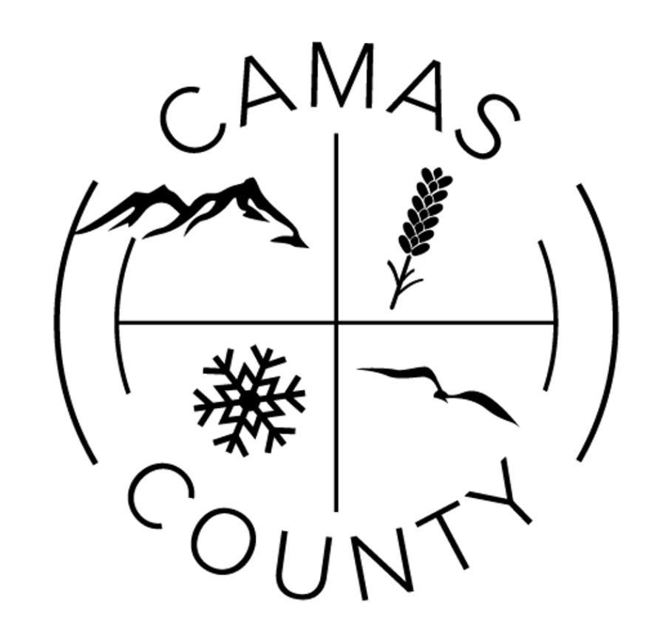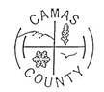
Camas County Board of Commissioners
Camas County Courthouse Annex, 517 Soldier Road
Commissioners Room
November 17, 2025

9:00 a.m. -5:00 p.m. (as time permits)
*Correspondence/Committee Reports
*Board of Equalization, as needed
*Executive Session, per Idaho Code §74-206(a)(b), as needed for personnel matters
*Executive Session, per Idaho Code §74-206(f), as needed for pending litigation
**Executive Session, per Idaho Code §31-874 for indigent matters
**Passthrough Funds Agreement signatures
**Road Ownership and Functional Class Map
**Preliminary Design Report for 500 East Bridge
*Discussion on County employee raises
*County Christmas Party

9:00 a.m.

*Call to Order
**Approval of the Agenda
**Review/ approve November 10, 2025 Meeting Minutes
**Review/ approve November 10, 2025 Synopsis for Commissioner Publication

9:15 a.m.- **Sheriff Martin – Continued discussion on budget line items

9:30 a.m.- **City of Fairfield Law Enforcement Agreement for FY 2026

9:45 a.m.-

10:00 a.m.- **Executive Session, per Idaho Code §31-874 for indigent matters

10:30 a.m.-

11:00 a.m.-

12:00 p.m.- 1:00 p.m. Lunch

1:00 p.m. -

2:00 p.m.-

2:30 p.m.-

NOTE: Meetings are open to the public except for executive sessions. However, if you are not on the agenda, you may not be recognized to speak. If you would like to speak during the meeting, please contact the County Clerk’s office to be placed on the agenda by Thursday prior to the meeting. Please contact the clerk’s office prior to any county meetings if there is any special assistance needed for people planning to attend. (208) 764-2242
**Refers to matters that an action is required**

