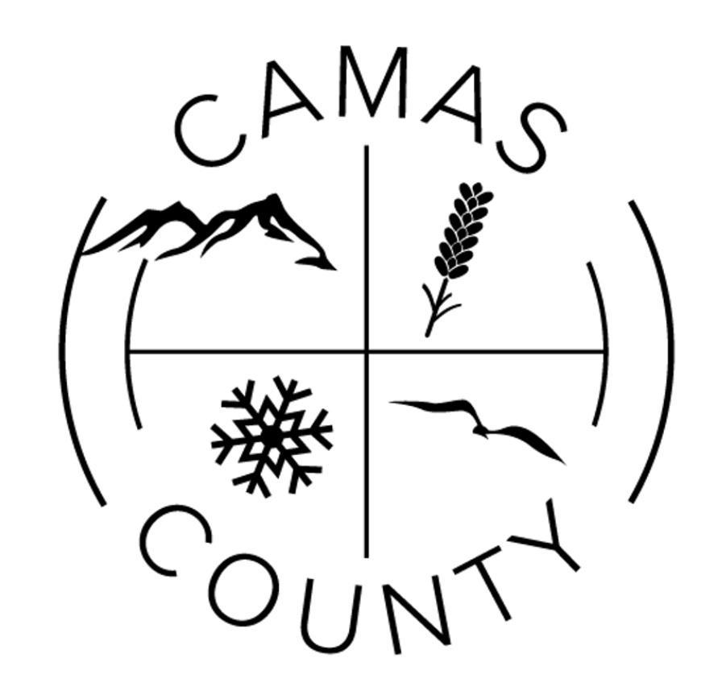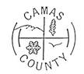
Camas County Board of Commissioners
Camas County Courthouse Annex, Commissioners Room
December 11, 2023

9:00 a.m. -5:00 p.m. (as time permits)
*Correspondence/Committee Reports
*Board of Equalization, as needed
*Executive Session, per Idaho Code 74-206(a)(b), as needed for personnel matters
*Executive Session, per Idaho Code 74-206(f), as needed for pending litigation
*Executive Session, per Idaho Code 31-874, as needed for indigent matters
*Broadband update
*Review Personnel Policy
**Review / approve November Claims
**Review Commissioner Calendar for 2024
**Elk Creek Road Abandonment Procedure Resolution
**Portion of Bryant Lane/N600 E Road Abandonment Procedure Resolution
**Ambulance claim for deceased
**Homeland Security Subrecipient Agreement
**Liquor Licenses
*Discussion on Code Enforcement
*County Christmas Party
**Annual Road and Street Financial Report
**Capital Project Funds Broadband Grant Agreement

9:00 a.m.
*Call to Order
**Approval of the Agenda
**Review/ approve December 4, 2023 Meeting Minutes
**Review/ approve December 4, 2023 Synopsis for Commissioner Publication

9:30 a.m. – County Assessor Lynn McGuire--**Homeowner Occupancy
9:45 a.m. – Pam Jones -- *Health Department Update

12:00 p.m – 1:00 p.m. Lunch

NOTE: Meetings are open to the public except for executive sessions. However, if you are not on the agenda, you may not be recognized to speak. If you would like to speak during the meeting, please contact the County Clerk’s office to be placed on the agenda by Thursday prior to the meeting. Please contact the clerk’s office prior to any county meetings if there is any special assistance needed for people planning to attend. (208) 764-2242
**Refers to matters that an action is required**

